**The RFR Picnic**

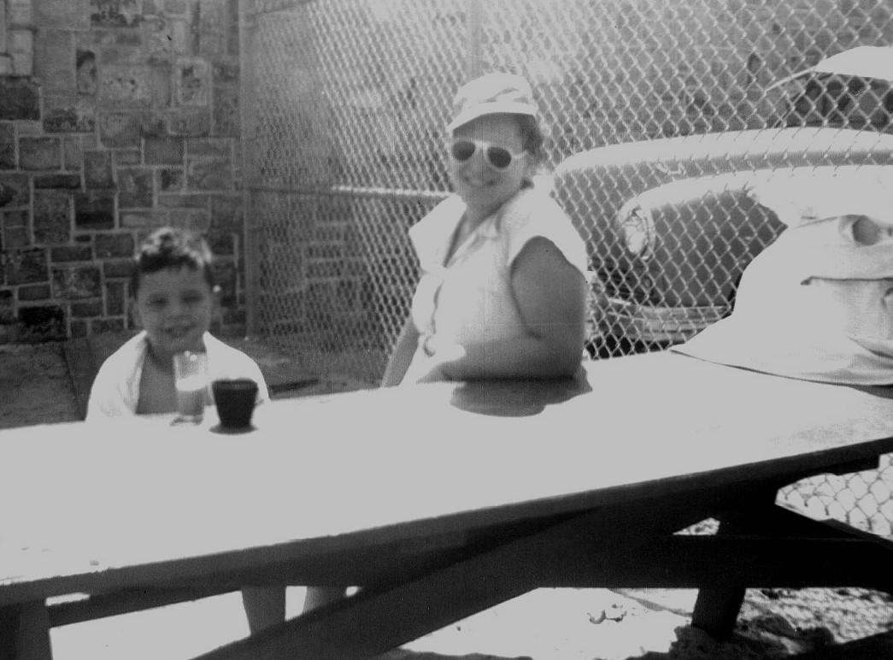The picnic will be held on Saturday at Bill Barber Memorial Park from 12 noon until 3pm. We have reserved a covered picnic area (#4) where the Gen S group will be providing sandwiches, chips, drinks and snacks. The picnic area is close to both a playground and open grassy areas. Slides, swing sets, balls and Frisbees will hopefully lure members of the RFR away from the ever-present siren song of social media.