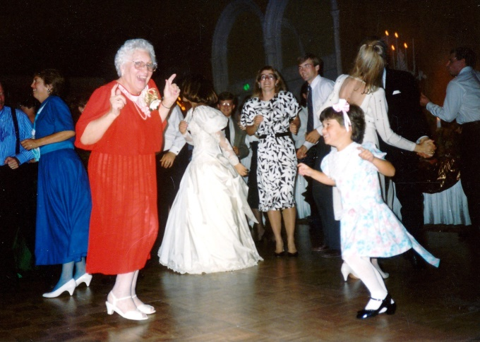Hedgehog Hop

Your ever vigilant RFROC has learned from the Embassy Suites that the room that we will be meeting/dining in will have space for a small impromptu (carpeted) dance floor.

One of the Gen S daughter-in-laws (Doni Ricci) has volunteered to survey the group to see if there is an interest in having dancing available. She is also willing to organize a play list from suggestions submitted to her.

Please respond to her by replying to the following email address: [contact RFROC for her address]

|  |  |  |
| --- | --- | --- |
|  | Yes | No |
| I would like to have dancing available |  |  |
| I would be willing to submit titles for the play list |  |  |

If you expressed an interest (above) in helping plan the playlist, Doni will contact you directly with instructions on how/where to submit your suggestions.

***Your Swingin’ and Swayin’ RFROC***